Experiment 7: Analog Beamforming Analysis Using MATLAB
Aim
To analyze the performance of analog beamforming by studying beamforming gain, beam width, and main lobe direction using MATLAB.
Objectives
1. To analyze the beamforming gain achieved by varying the number of antenna elements in
an analog beamforming system using MATLAB.
2. To compare the beam width of an antenna array for different beamforming configurations
using MATLAB.
3. To analyze the main lobe direction by steering the antenna array beam to different angles
using MATLAB.
Objective – 1
Analyze Beamforming Gain (dB) Generate beamforming gain values for different antenna array sizes using MATLAB. Compare how increasing the number of antenna elements improves the beamforming gain and enhances signal strength.
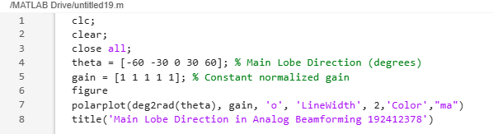
MATLAB Code:

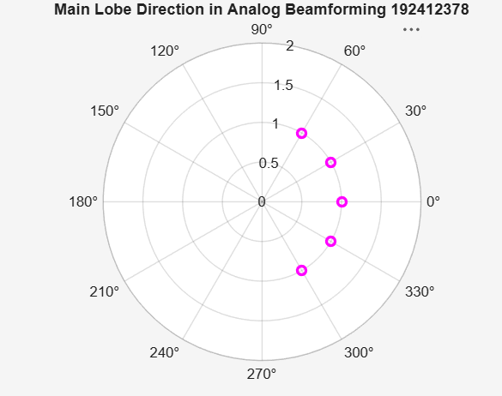
Expected Output

Objective – 2
Compare Beam Width (Degrees)Analyze the beam width corresponding to different antenna array sizes using MATLAB. Observe how increasing the number of antenna elements results in a narrower beam, thereby improving spatial resolution.
MATLAB Code:

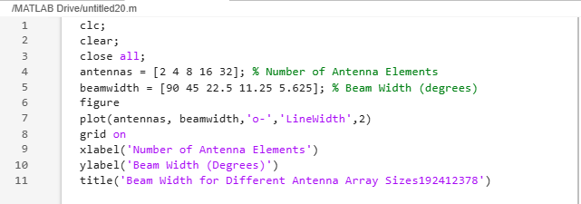

Expected Output
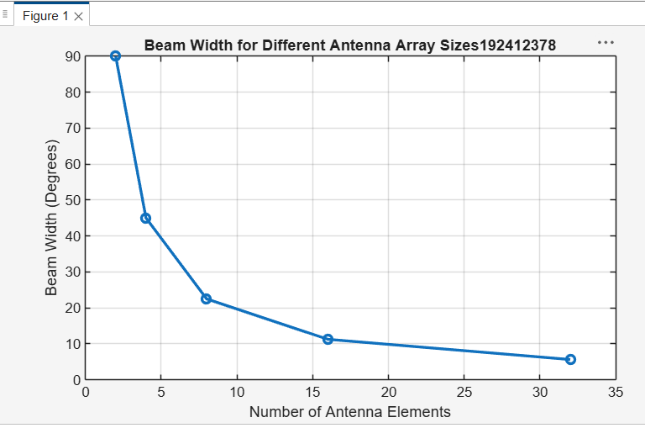

Objective – 3
Analyze Main Lobe Direction (Degrees) Simulate beam steering by varying the steering angle of the antenna array using MATLAB. Observe the change in the main lobe direction and understand how analog beamforming directs energy toward the intended user.
MATLAB Code:
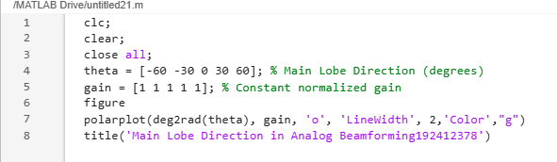

Expected Output
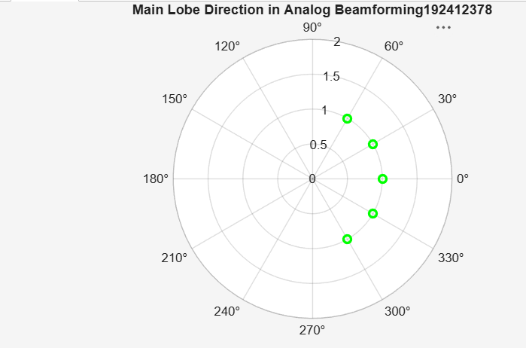

Result
The MATLAB analysis successfully demonstrated the characteristics of analog beamforming. The results showed that increasing the number of antenna elements improves beamforming gain and reduces beam width, while phase adjustment enables the main lobe to be steered toward different.

